**UNDP Ajeevika Project**

*Installation Guide*

Link to repo: <https://github.com/UNDPIndia/Aajeevika>

The repository has the following files:

* All User manual (Admin, Buyer, Seller, SHG Individual, Collection Centres)
* Software Requirement Specifications (SRS)
* Testing Cases & Report
* ER Diagram
* Infrastructure Requirement
* Server Config

The undp-backend repository has all the API’s, Admin, and website code.

We can give this repository access to anyone who has a GitHub account. If you don’t

have a GitHub account, then you can create a new account on github.com

To give access, select the repository and go to the settings tab.

There are multiple options in the left panel where you’ll see Manage access (under Collaborators). You need to click on manage access and then click on the invite teams or people button.

After clicking on that button, a popup will appear that will ask you to enter the GitHub username. You can enter the GitHub username and that user will get an invitation email on their email account which is used at the time of sign up. The user needs to click on accept invite button.

You can use Visual Studio Code IDE to open the project. Where you can use the git clone command to access the code.

For the git command please use the below links.

<https://git-scm.com/docs/git>

**Set up Laravel project on Localhost**

Step 1. download Xampp

Go to this website https://www.apachefriends.org/download.html and download Xampp PHP version 7.

Step 2. Install Xampp to your PC.

Double click on the Xampp installer that was downloaded and it should launch a wizard.

The default setup is normally recommended. Therefore, continually click next in each step until the wizard start installing all the packages.

Step 3. Copy Laravel project to Xampp.

Copy and paste the project in "C:\xampp\htdocs".

Step 4. Start the Xampp servers

Launch the Xampp Control Panel via the Xampp app icon. If you cannot see the Xampp app icon just search for it in Windows search feature. Once the control panel is launched, click on the Apache and MySql start buttons. If port 80 and port 3306 are not available, you might get errors and the servers will not start.

Step 5. Download composer

Go here "<https://getcomposer.org/download/>" and download composer-setup.exe. Just click through the step for a basic install. Skip the step that will ask you to add a Proxy URL. Click finish once install is complete.

Step 6. Test composer

Open the command prompt on your PC and write the command "composer -v"

You can now see composer has been install successfully.

Step 7. Create and Import database on server.

Once Apache and MySql as started successfully open a browser such as chrome, copy and paste the url "http://localhost/phpmyadmin" then open phpMyAdmin. You should see the phpMyAdmin panel, click on the database tab in order to create a new database and import database.

Database Path: C:\xampp\htdocs/”project name/”src/database.

DB Name: aajiveeka_testing

Step 6. Configure .env file to connect with Xampp database.

Go to your .env file and edit the database section as below:

Step 7. launch project

Once all the steps are completed successfully launch the Laravel project in a browser "[http://localhost/yourlaravelprojectname/public/](http://localhost/flash-message/public/)". If you created the project from command line as in step 3 then your project name would be "example-app".

Or

First of open CMD

CMD -> cd (go to your project directory )

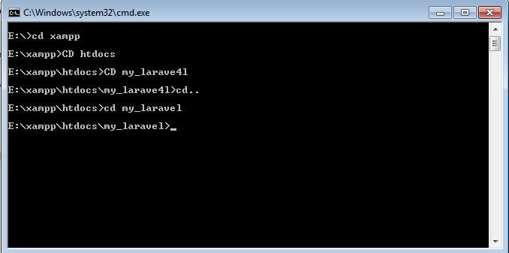

CMD -> CD php artisan serve

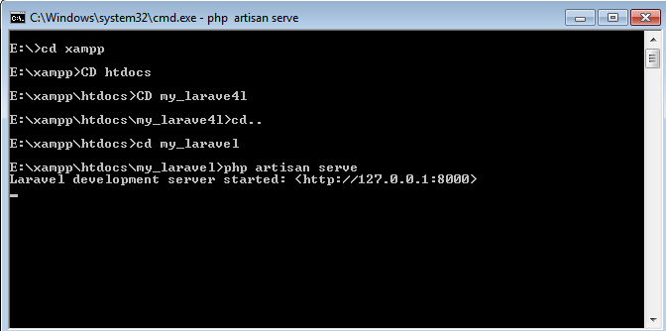

Than run that url [http://127.0.0.1:8000](http://127.0.0.1:8000/)

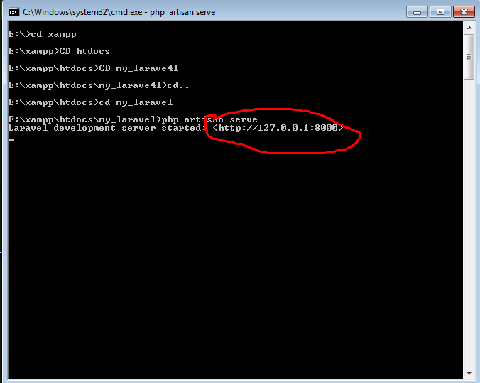

**Ajeevika Server Setup on AWS**

Log on to AWS & click on Launch Instance Button:

Name your Instance

Select OS for your Instance: In this case select 18.04 LTS

Select Instance type: **t3.small** in this case & add or create a Key value pair.

Select Storage: 30 Gb is recommended.

Review Your Server Config and click on **Launch Button.**

Now connect with your Server with SSH Client.

1. Open an SSH client.
2. Locate your private key file. The key used to launch this instance is oro.pem
3. Run this command, if necessary, to ensure your key is not publicly viewable.
4. Connect to your instance using its Public DNS.

One Ubuntu 18.04 server (t3a.micro). This server should have a root administrative user and a firewall configured with UFW. Ubuntu’s official package repositories include a stable version of MongoDB/MYSQL/PHP/NodeJS.

* **MongoDB** available from the default Ubuntu repositories is 5.4

To start, import the public GPG key for the latest stable version of MongoDB by running the following command listed on MongoDB official page.

Then check the service status:-

* **sudo systemctl status mongod**

Create users/password attached with default port 27017.

* **Apache** on Ubuntu server. Apache is web server software and a popular HTTP client; it helps in creating virtual hosts.
  + **sudo apt update** -(update System)
  + **sudo apt install apache2** -(Install Apache2)
* **sudo apt install apache2 –** (Start Apache2)
* We have installed **PHP 7.4** on the server with the modules (Curl, Php-cli, Php-mbstring, git, unzip, GuzzleClient, Composer) that you require for your project.
* **sudo apt-get update**
* **sudo apt -y install software-properties-common**
* **sudo add-apt-repository ppa:ondrej/php**
* **sudo apt-get update**
* **sudo apt -y install php7.4**
* **php -v**
* **sudo apt-get install -y php7.4-cli php7.4-json php7.4-common php7.4-mysql php7.4-zip php7.4-gd php7.4-mbstring php7.4-curl php7.4-xml php7.4-bcmath**

1. Check the service status:-

* **Sudo system status apache2.service**

1. **MySQL** is a database management system. Basically, it will organize and provide access to databases where our site can store information.

Simple security script that will remove some dangerous defaults and lock down access to our database system a little bit. Start the interactive script.

* **sudo apt update**
* **sudo apt install mysql-server**
* **sudo systemctl start mysql.service**
* **sudo mysql_secure_installation**

1. **PhpMyAdmin** is GUI web software to work with MySQL on the web—it provides a convenient visual front end to the MySQL capabilities.

PhpMyAdmin will now be much more secure since only authorized users will be able to reach the login page.

Check the service status:-

* **Sudo systemctl status mysqld**

1. In addition, it also has incredible support for major **Node.js** frameworks with PM2 and

NPM is a package manager that you will use to install express frameworks and libraries (NestJs, Poet, ItemsAPI, Kraken, Blueprint,Kites,socket.io) with your Node.js applications.

Latest stable version of PM2 is available to install via NPM.

Check the service status with defines required port:-

* **Sudo pm2 list**

*To make changes in Codebase*

* Open VScode or Similar IDE
* Click on source Control, Connect with Github & Clone from Github.
* Copy & Paste link from Github in the box.
* Make necessary Changes and Push to Github by clicking the sync button in bottom.

**AWS Architecture Diagram**

An internet gateway is a horizontally scaled, redundant, and highly available VPC component that allows communication between your **VPC** and the internet.

This virtual network (VPC) resembles a traditional network that you'd operate in your own data center, with the benefits of using the scalable infrastructure of AWS.

The AWS Global Infrastructure gives you the flexibility of choosing how and where you want to run your workloads, and when you do you are using the same network, control plane, API’s, and AWS services

**Git** allows and encourages you to have multiple local branches that can be entirely independent of each other. The creation, merging, and deletion of those lines of development take seconds.

